Auto Ticket Classification using Flow Designer
6. Project Testing Phase

6.1 Testing Overview
The testing phase verifies that the Auto Ticket Classification using Flow Designer project works according to the defined requirements. Testing focuses on the end-to-end automation process, including ticket creation, keyword-based classification, Category and Subcategory updates, and email notification.
The validation process checks whether the mandatory information is captured correctly, whether the ticket receives the expected classification, and whether the Caller receives the configured confirmation email. Different ticket descriptions are used to validate the configured classification branches.

6.2 Testing Objectives
- Verify that a new IT ticket can be created successfully.
- Verify that the Flow Designer trigger starts for a newly created ticket.
- Verify that WiFi-related tickets are classified as Network / Wi-Fi.
- Verify that Projector-related tickets are classified as Hardware / Projector.
- Verify that Password or Login-related tickets are classified as Access / Forgot Password.
- Verify that Slow or Hanging computer tickets are classified as Performance / Slow Computer.
- Verify that the confirmation email is sent to the Caller.
- Verify that ticket information is stored in a structured format.

6.3 Testing Flowchart
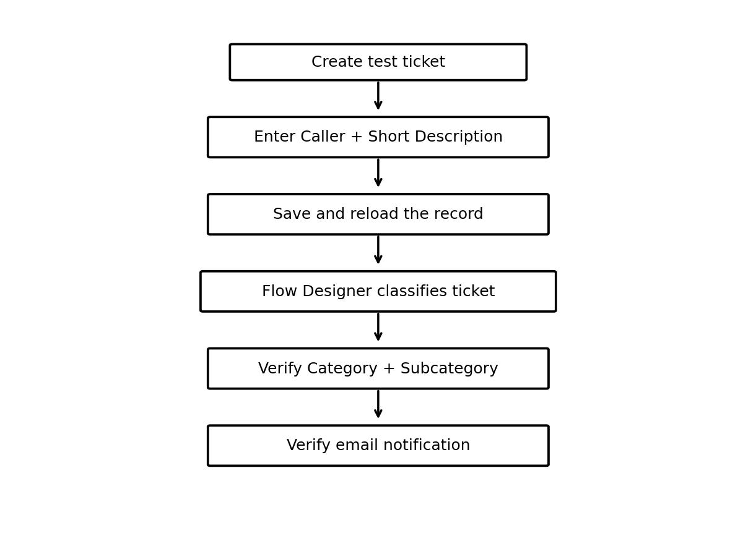
Figure 6.1: End-to-End Testing Flow

6.4 Test Scenario 1 – WiFi Issue
- Open the Incident Workflow form.
- Enter a Caller name.
- Enter Short Description: “WiFi not working in library”.
- Save the form and reload the record.
- Verify Category = Network.
- Verify Subcategory = WiFi.
- Verify that the confirmation email is sent to the Caller email address.

6.5 Test Scenario 2 – Projector Issue
- Open the Incident Workflow form.
- Enter a Caller name.
- Enter Short Description: “Projector not turning on”.
- Save the form and reload the record.
- Verify Category = Hardware.
- Verify Subcategory = Projector.
- Verify that the confirmation email is sent to the Caller email address.

6.6 Test Coverage Table
Test Case | Input | Expected Category | Expected Subcategory | Expected Result
TC-01 | WiFi not working in library | Network | WiFi | Pass if values auto-fill correctly
TC-02 | Projector not turning on | Hardware | Projector | Pass if values auto-fill correctly
TC-03 | Forgot password / Login issue | Access | Forgot Password | Pass if values auto-fill correctly
TC-04 | Computer is slow / hanging | Performance | Slow Computer | Pass if values auto-fill correctly
TC-05 | Any classified ticket | — | — | Pass if confirmation email is received

6.7 Email Notification Verification
- Open All menus and search for Emails.
- Under System Logs, select Emails.
- Search using the configured subject name.
- Open the matching email record.
- Use the Preview mail option under Related Links.
- Verify that the recipient is the Caller and that the ticket confirmation message is present.

6.8 Data Validation Checks
- Mandatory fields are captured correctly.
- Auto-number is generated without duplication.
- Category and Subcategory values are stored accurately.
- Reference fields resolve correctly to the related user and group records.
- The ticket remains structured and standardized after automation.

6.9 Expected Testing Result
The expected result of testing is that each supported issue description is automatically classified according to the configured Flow Designer conditions. The ticket should display the correct Category and Subcategory after the record is saved and reloaded. The Caller should also receive the configured confirmation email. Successful completion of these checks demonstrates that the developed automation performs the intended ticket classification workflow.

